**Barbie Hsu**

**Actress, Singer and Talkshow Host**



Hsi-yuan Hsu is the original name of the Taiwanese actress, singer and reality show host known on stage as Barbie Hsu. She was born in Taiwan on 6 October, 1976 in Taiwan and is the middle child of a family with three children. Barbie is1.63 metres tall. She is best known for her 2001 star performance in *Meteor Gardens,* a television series, and her lead roles in [*Connected*](https://www.imdb.com/title/tt1156506?ref_=nm_ov_bio_lk1) (2008) and *[Croczilla](https://www.imdb.com/title/tt2354196?ref_=nm_ov_bio_lk3)*(2012).

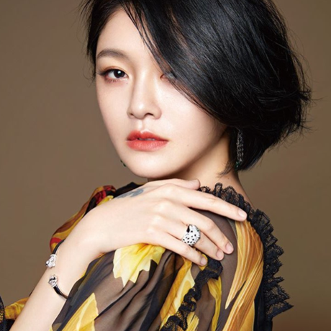

Barbie can only be described as versatile and extremely talented. This is evident in her career that has so far seen her appearing in 113 TV Episodes, 16 feature films and 9 TV Series. Although she is well known for starring in romance episodes she is highly respected for her performances in at least 59 drama, 53 comedy, and numerous talk shows and realty shows.

She got married to [Xiaofei Wang](https://www.imdb.com/name/nm8968301?ref_=nm_ov_bio_lk4), a wealthy Chinese entrepreneur who is five years younger than her, in November 16, 2010. The relationship was sealed in a simple civil ceremony but they threw a lavish wedding banquet early in 2011 on Hainan Island, a province of China with exotic beach resorts, breath-taking mountains and fantastic tropical weather.

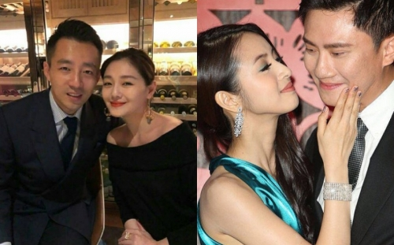

The couple now have two children after a long spell in which she was unable to conceive. She was only able to have her first child, a girl, at an advanced age of 37 on April 24, 2014. She is currently trying to have a third child and is pregnant again even though she had previously announced she would not seek another child. However, she was recently hospitalized in Taipei amidst fears of epileptic feats that might affect her pregnancy.

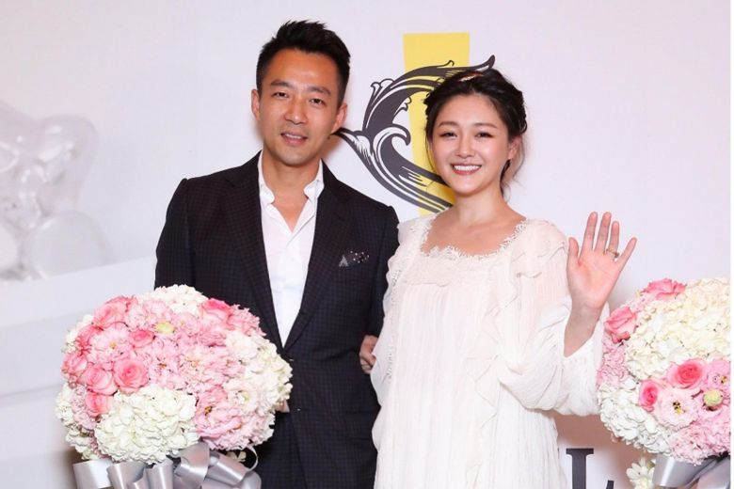

In an interview with *Apple Daily,* Barbie who is now 41 expressed fears and apprehension. As she put it, "because my body can't really take it, I'm too old". "The lesson I've learned from this pregnancy is that people really can't be too tee kee. After I had my second child, I said I would never have another one, but I became pregnant after I lost weight. I can't say such tee kee words anymore."

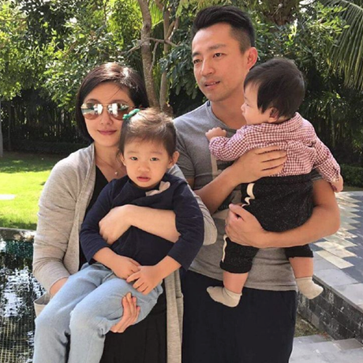

Of course as an actress one of the challenges she has is controlling her weight. She was criticized by *Netizens* in 2016 for her inability to “shed her post-baby weight” quickly enough. Thereafter she made concerted efforts to regain her pre-pregnancy body weight by going on a strict diet that resulted in losing 10 kilograms in one month.

This confirms her mother’s statement about Barbie’s determination to succeed in life. Her mother had told her husband earlier on at the beginning of their relationship that “[If] your wife wishes to do something, no one can stop her.” She is likely to face the same challenge this time around. She became more lax about her idea of vegetarianism after the first child and began to eat fast food. Her husband reports that she has since abstained from junk food and engages in a lot of physical exercises. Her breakfast is simply a quarter of a dragon fruit while for lunch she usually takes two slices of meat and two bowls of blanched vegetables with no rice at all.

Barbie also thanked her husband for his moral support and a surprise gift she got from him last Christmas. The husband, Xiaofei, named his new boutique hotel after his wife, Big S Hotel. Despite rumours of marital issues including poor relationship with her mother-in-law, the relationship appears to be waxing stronger.



Prior to taking up acting, she paired with her younger sister Dee Hsu from 1994 to 2001 in the pop duo originally known as *Sisters of Shu* (SOS) but later to be known as ASOS because of a legal challenge to their name. While in the pop duo she acquired the nickname “Big S” and her younger sister was known as "Little S".

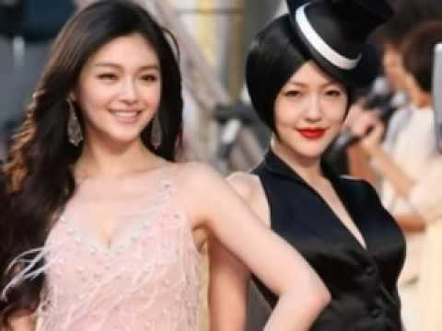

**Sisters of Shu (ASOS)**

Barbie says she is going back to being a vegetarian because she is an animal-lover and cannot reconcile herself with eating food that includes animal protein. Barbie Hsu appears to have gone into early retirement since her marriage in 2010. She has not released any works since 2012. However she has continued as an ambassador for Tissot watches, a role she has played since 2005.